**Alpha Beta Pruning in AI**

Alpha-Beta Pruning, a fundamental concept in optimizing minimax search algorithms. We'll explore the significance of Alpha-Beta Pruning and its applications in game-playing AI and decision trees.

**The Importance of Alpha-Beta Pruning**

Alpha-Beta Pruning plays a pivotal role in optimizing the minimax algorithm, which is used for decision-making in two-player games. Its significance lies in its ability to drastically reduce the search space, allowing the algorithm to explore only the most promising branches of the game tree while discarding unfruitful ones.

**Applications of Alpha-Beta Pruning**

Alpha-Beta Pruning finds extensive use in game-playing AI, where computational efficiency is crucial. It's the technique that allows AI agents to make intelligent decisions within a reasonable time frame in games like chess, checkers, and even video games. Additionally, Alpha-Beta Pruning is applicable in decision trees used in fields such as finance, logistics, and optimization problems, where making the right decisions quickly is essential.

**Overview of the Minimax Algorithm**

Before we dive into Alpha-Beta Pruning, let's start with a brief overview of the Minimax algorithm. Minimax is a decision-making algorithm used in two-player games, where one player maximizes their outcome, and the other player aims to minimize it. It's a fundamental concept in game theory and artificial intelligence.

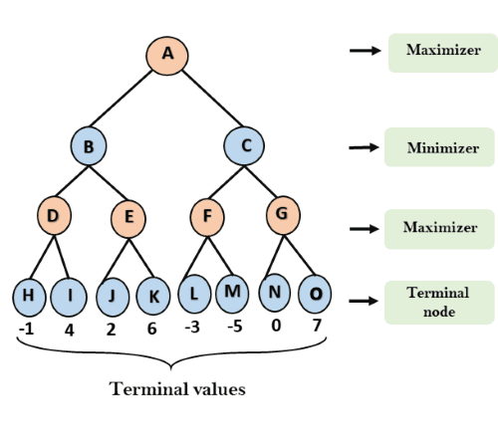

Minimax in AI

**Minimax in Two-Player Games**

Minimax is employed to determine optimal strategies in games like chess, checkers, and tic-tac-toe. In a two-player game, one player takes on the role of the maximizer, seeking the best move to maximize their chances of winning, while the other player acts as the minimizer, attempting to minimize the maximizer's chances.

**Exploring the Game Tree**

To find optimal strategies, Minimax explores the game tree, which represents all possible moves and outcomes in the game. The tree starts at the current game state and branches out, considering all possible moves. The algorithm recursively evaluates these moves, assuming that both players make optimal decisions, to determine the best course of action.

As we explore Alpha-Beta Pruning, keep in mind that it is a technique used to enhance the efficiency of Minimax by pruning unproductive branches of the game tree. It enables AI agents to make strategic decisions in real time, making it a critical component of game-playing AI.

**Defining the Problem of Alpha Beta Pruning in Artificial Intelligence**

Alpha-Beta Pruning aims to address a crucial issue in search algorithms, particularly in the context of two-player games. The problem it tackles is the need to reduce the search space in the game tree. In game trees, each node represents a possible game state, and branches represent potential moves. As the tree deepens, the number of nodes grows exponentially, resulting in a vast and often unmanageable search space.

**Challenges of Excessive Search**

Exhaustively searching large game trees presents several significant challenges:

**Computational Complexity:** As the game tree expands, the computational effort required to explore all possible moves increases exponentially. This is impractical for many real-time applications where decisions must be made quickly.

**Memory Consumption:** Storing and processing the game tree can consume a substantial amount of memory, potentially exceeding the available resources.

3. **Inefficiency:** Without optimization, exhaustive search algorithms can waste time exploring unproductive branches of the game tree, leading to inefficient decision-making.

Alpha-Beta Pruning comes to the rescue by allowing us to skip unnecessary branches, drastically reducing the computational workload and enabling AI agents to make strategic decisions in a timely manner. It's a technique that maximizes the efficiency of minimax search in game-playing AI.

**Understanding Alpha and Beta Values**

Alpha and Beta values are key components of Alpha-Beta Pruning, and they play a crucial role in optimizing the minimax search algorithm. Let's explore these concepts:

**Alpha and Beta**

* **Alpha:** Alpha represents the best score that the maximizing player has found so far in a particular branch of the game tree. It is the highest score the maximizing player can achieve up to this point. Essentially, it tracks the maximizer's best-known option.
* **Beta:** On the other hand, Beta represents the best score that the minimizing player has found in a specific branch. It is the lowest score the minimizing player can allow up to this point. Beta tracks the minimizer's best-known option.

**Initial Values of Alpha and Beta**

At the beginning of the Alpha-Beta Pruning process, we set the initial values of Alpha and Beta to represent the extremes of possible scores:

* **Alpha** is initially set to negative infinity, symbolizing the worst possible score for the maximizer.
* **Beta** is initially set to positive infinity, indicating the best possible score for the minimizer.

As the Alpha-Beta Pruning algorithm in AI progresses and evaluates nodes, Alpha and Beta are updated to reflect the best-known values for each player within a specific branch. These initial values are crucial to the pruning process, allowing us to efficiently identify promising branches and discard unproductive ones.

**Pseudo Code for Alpha-beta Pruning**

function AlphaBeta(node, depth, alpha, beta, maximizingPlayer):

if depth == 0 or node is a terminal node:

return the heuristic value of node

if maximizingPlayer:

maxEval = -infinity

for each child of node:

eval = AlphaBeta(child, depth - 1, alpha, beta, false)

maxEval = max(maxEval, eval)

alpha = max(alpha, eval)

if beta <= alpha:

break // Beta cutoff

return maxEval

else:

minEval = infinity

for each child of node:

eval = AlphaBeta(child, depth - 1, alpha, beta, true)

minEval = min(minEval, eval)

beta = min(beta, eval)

if beta <= alpha:

break // Alpha cutoff

return minEval

**Step by Step Breakdown of  the Alpha-Beta Pruning Pseudo-Code:**

1. **Base Case**:
   * **Depth 0 or Terminal Node**: If the current depth is 0 or the node is terminal (no further moves possible), return the heuristic value. This provides a score for the current state.
2. **Maximizing Player's Turn**:
   * **Initialization**: Start with maxEval set to negative infinity, as we're trying to find the highest possible value.
   * **Iterate Over Children**: For each child node, call the AlphaBeta function recursively to evaluate it.
   * **Update** **maxEval**: After evaluating a child, update maxEval to be the maximum of its current value and the evaluated child's value.
   * **Update** **alpha**: Adjust alpha to the highest value found so far. If alpha exceeds or equals beta, prune the remaining children (cut off further exploration).
3. **Minimizing Player's Turn**:
   * **Initialization**: Start with minEval set to positive infinity, as we're trying to find the lowest possible value.
   * **Iterate Over Children**: For each child node, call the AlphaBeta function recursively to evaluate it.
   * **Update** **minEval**: After evaluating a child, update minEval to be the minimum of its current value and the evaluated child's value.
   * **Update** **beta**: Adjust beta to the lowest value found so far. If beta is less than or equal to alpha, prune the remaining children (cut off further exploration).
4. **Pruning Condition**:
   * **Cutoff**: If at any point, alpha (best for maximizer) becomes greater than or equal to beta (best for minimizer), prune the remaining child nodes as they can't improve the outcome. This is the core of Alpha-Beta pruning.
5. **Return**:

* **Best Value**: Finally, return maxEval for the maximizing player or minEval for the minimizing player, representing the best decision possible at this node given the current search depth and evaluated branches.

**Alpha Beta Pruning Algorithm with an Example**

Let's now walk through the Alpha-Beta Pruning process step by step, using a simple example to illustrate the concept. In this example, we'll use a small game tree to demonstrate how Alpha-Beta Pruning works.

1. **Initialization:**

* We begin with the root node of the game tree.
* Initialize Alpha as negative infinity and Beta as positive infinity. This means that the maximizer's best score is initially set to negative infinity, and the minimizer's best score is initially set to positive infinity.

2. **Exploring the Tree:**

* We explore the tree depth-first, considering each node and its possible moves.
* As we evaluate each node, we update the Alpha and Beta values.

3. **Updating Alpha and Beta:**

* When we evaluate a maximizing (Max) node, we update Alpha to the maximum of its current value and the evaluation result. It represents the best-known option for the maximizing player.
* When we evaluate a minimizing (Min) node, we update Beta to the minimum of its current value and the evaluation result. It represents the best-known option for the minimizing player.

4. **Pruning:**

* The magic of Alpha-Beta Pruning happens when we determine that a branch is not worth exploring further. We do this by comparing Alpha and Beta.
* If at any point, Alpha becomes greater than or equal to Beta, it indicates that we've found a better option elsewhere. So, we can safely prune the rest of the branch because it won't affect the final result.

Alpha Beta Pruning Example Step by Step:

For a practical demonstration, let's consider a small game tree, such as a Tic-Tac-Toe scenario, where we can apply Alpha-Beta Pruning to see how it efficiently prunes unproductive branches. We'll show how the pruning process reduces the number of nodes to evaluate, saving time and computational resources. This practical example will make the Alpha-Beta Pruning concept clearer.

**Tic-Tac-Toe Example:**

Imagine a Tic-Tac-Toe game tree where the AI is the maximizing player, and the opponent is the minimizing player. The game tree looks like this:

Max's Turn (AI)

| | X

---------

| O |

---------

X | | O

Min's Turn (Opponent)

* We start at the root node (Max's turn) with Alpha as negative infinity and Beta as positive infinity.
* We evaluate the first child node, which represents Max's move to the top-right corner. The evaluation result is -10 (Max doesn't have a winning move here).
* We update Alpha to -10.

Now, as we move to the next child node (Min's turn), we find that the opponent has a choice between the bottom-left and bottom-right corners. We evaluate the first child node (bottom-left) and get an evaluation result of 5. We update Beta to 5.

At this point, we can prune the rest of the branch because Alpha (-10) is less than Beta (5). It means that, as the maximizing player, we already have a better option elsewhere. So, we don't need to explore further.

This pruning process continues as we traverse the tree. We quickly identify branches that won't lead to better results, and we eliminate the need to evaluate them fully. In this way, Alpha-Beta Pruning efficiently reduces the search space, making the AI's decision-making process faster and more resource-efficient.

**Example of** **Alpha-Beta Pruning with a More Complex Game Tree:**

Let's consider a more complex Tic-Tac-Toe game tree to showcase the efficiency of Alpha-Beta Pruning. In this tree, we'll apply Alpha-Beta Pruning to compare the number of nodes evaluated with and without pruning.

Max's Turn (AI)

| X |

---------

| O | O

---------

X | |

Min's Turn (Opponent)

* We start at the root node (Max's turn) with Alpha as negative infinity and Beta as positive infinity.
* We evaluate the first child node, where Max places an 'X' in the top-center position. The evaluation result is -10 (Max doesn't have a winning move here). We update Alpha to -10.

As we move to the next child node (Min's turn), we find that the opponent has two available moves, which leads to a branching factor of 2:

* In the first branch, Min selects the bottom-left corner. The evaluation result is 5. We update Beta to 5.
* In the second branch, Min chooses the bottom-center position. The evaluation result is -5. We update Beta to -5.

At this point, we can prune the second branch (Min's move to the bottom-center) because Alpha (-10) is already greater than or equal to Beta (-5). This branch won't affect the final result, so we eliminate the need to explore it further.

**Comparing Pruned vs. Unpruned Evaluation:**

Now, let's compare the number of nodes evaluated with and without Alpha-Beta Pruning in this scenario:

* Without Pruning: In a full evaluation without pruning, we would have to explore both branches, evaluating four nodes in total (two for Max, two for Min).
* With Pruning: With Alpha-Beta Pruning, we only need to evaluate the first branch, which means we evaluate two nodes (one for Max, one for Min) and prune the second branch.

This demonstrates how Alpha-Beta Pruning significantly reduces the number of nodes that need to be evaluated, resulting in a more efficient and faster decision-making process for the AI. It's a crucial technique for optimizing minimax search algorithms in complex game scenarios.

**Variations of Alpha Beta Pruning:**

While Alpha-Beta Pruning is the fundamental technique for optimizing minimax search, there are variations and enhancements that offer different advantages in specific situations. Let's briefly mention a few:

* **Alpha-Beta with Cutoffs:** This variation involves using cutoffs based on more complex conditions than the simple comparison of Alpha and Beta. For example, if we encounter a "quiescent" position (one with a significant change in the evaluation function), we might extend our search to better understand the position before applying pruning. This can be especially useful in games with tactical complexities.

**Importance of Move Ordering and Potential Pitfalls:**

One critical aspect of successful Alpha-Beta Pruning is move ordering. The order in which you explore moves can significantly impact the pruning efficiency. Here's why it matters:

* **Best Moves First:** If you explore the best moves first, you're more likely to encounter alpha-beta cutoffs early in the search, leading to faster pruning.
* **Worst Moves Later:** If you explore less promising moves first, you might delay pruning and evaluate more nodes before reaching a cutoff.

**Potential Pitfalls:**

* **Inaccurate Heuristics:** Using poor heuristics can lead to premature pruning or a failure to prune when it's possible. Accurate heuristics are crucial.
* **Misordering of Moves:** If you explore moves in a suboptimal order, it can result in inefficient pruning. Effective move ordering strategies, like ordering moves based on captures in a chess game, are essential.
* **Fail-High and Fail-Low Situations:** Sometimes, alpha-beta pruning can lead to unexpected situations, where you reach a cutoff because you underestimate a position (fail-low) or overestimate it (fail-high). Strategies to handle these situations are important.

Understanding the nuances and potential pitfalls of Alpha-Beta Pruning, along with careful move ordering, is critical for making the most of this technique in AI decision-making.

**Practical Applications of Alpha-Beta Pruning**

Alpha-Beta Pruning is a fundamental technique with practical applications in various domains. Let's discuss some of these applications:

* **Chess Engines:** Alpha-Beta Pruning is widely used in chess engines to evaluate and compare various move sequences efficiently. It allows chess AI to explore deep into the game tree and choose the best move while significantly reducing computational requirements.
* **Board Games:** Beyond chess, Alpha-Beta Pruning is applied to various board games like checkers, Othello, and Go, helping AI players make strategic decisions.
* **Video Games:** In video game development, Alpha-Beta Pruning is used to create AI opponents that can make intelligent moves in real-time strategy games, ensuring challenging gameplay.
* **Route Planning:** Alpha-Beta Pruning finds applications in pathfinding and route planning, such as GPS navigation systems, where it helps identify the most efficient routes.
* **Decision Trees:** Alpha-Beta Pruning can be employed in decision trees for decision-making processes. This is applicable in financial planning, logistics, and other decision-support systems.

**Efficiency in Strategic Thinking:**

Alpha-Beta Pruning enhances AI's efficiency in strategic thinking in various ways:

1. **Depth-First Search Optimization:** Alpha-Beta Pruning optimizes minimax search, allowing AI to explore deeper into the game tree, which is crucial for making better strategic decisions.

2. **Resource Efficiency:** By reducing the number of nodes to evaluate, Alpha-Beta Pruning conserves computational resources, enabling AI to think more deeply and analyze a broader range of potential moves.

3. **Real-Time Decision-Making:** In applications like video games, Alpha-Beta Pruning enables AI to make intelligent decisions in real-time, creating challenging and dynamic gameplay.

4. **Complex Problem Solving:** In complex problem-solving scenarios, Alpha-Beta Pruning helps AI make optimal choices, whether it's in a game, route planning, or decision-making systems.

Overall, Alpha-Beta Pruning plays a vital role in making AI-driven systems efficient and effective in strategic thinking and problem-solving, resulting in enhanced decision-making capabilities.

**Challenges in Alpha-Beta Pruning**

Alpha-Beta Pruning is a powerful technique, but it's not without its challenges. Let's explore a couple of key challenges:

1. **Heuristic Evaluation Function:** Alpha-Beta Pruning relies on an accurate heuristic evaluation function to estimate the value of a game position. If the heuristic is poorly designed or inaccurate, it can lead to premature pruning or inefficient search. Developing a good heuristic is both an art and a science and requires domain-specific knowledge.

2. **Memory Consumption:** While Alpha-Beta Pruning improves the efficiency of the search process, it can still consume a significant amount of memory, especially in games with large branching factors. Balancing computational resources is a challenge in resource-constrained environments.

3. **Fail-Soft and Fail-Hard Issues:** In some cases, if the heuristic function underestimates or overestimates a position, it can lead to unexpected outcomes in the pruning process. Handling these "fail-soft" (underestimate) and "fail-hard" (overestimate) scenarios can be challenging.

**Situations Where Alpha-Beta Pruning May Not Perform Optimally:**

While Alpha-Beta Pruning is highly effective in many scenarios, there are situations where it may not perform optimally:

1. **Games with Uncertainty:** In games involving chance elements, like poker or backgammon, Alpha-Beta Pruning may not be as effective due to the difficulty of accurately estimating probabilities.

2. **Complex Heuristics:** Games with complex or poorly understood evaluation functions can pose challenges for Alpha-Beta Pruning. The effectiveness of the pruning depends on the quality of the heuristic.

3. **Non-Admissible Heuristics:** If the heuristic used is inadmissible (overestimates the true cost), Alpha-Beta Pruning can lead to suboptimal or incorrect decisions.

4. **Parallel Execution:** In distributed or parallel computing environments, coordinating and synchronizing Alpha-Beta Pruning can be complex, particularly in real-time applications.

In such scenarios, other techniques or variations of Alpha-Beta Pruning, such as Monte Carlo Tree Search (MCTS) or probabilistic approaches, may be more suitable. Understanding the limitations of Alpha-Beta Pruning is essential for making informed decisions about its application in AI systems.

**Conclusion**

Alpha-Beta Pruning is a foundational technique in artificial intelligence that significantly enhances the efficiency of decision-making in games and optimization problems. Its ability to reduce the search space and focus on the most promising branches of a search tree has made it an indispensable tool in various AI applications. In summary:

* Alpha-Beta Pruning is a technique used in conjunction with the minimax algorithm to optimize the search for the best move in two-player games.
* It relies on the principles of maintaining upper and lower bounds (Alpha and Beta values) to prune branches of the search tree and reduce computational requirements.
* Proper move ordering, the choice of admissible heuristics, and understanding its limitations are crucial for the successful application of Alpha-Beta Pruning.
* Practical applications of Alpha-Beta Pruning span board games, video games, route planning, and decision trees, where it enhances strategic thinking and problem-solving efficiency.

**Key Takeaways**

* Alpha-Beta Pruning optimizes the minimax algorithm, reducing the number of nodes to evaluate and conserving computational resources.
* Move ordering plays a critical role in the efficiency of Alpha-Beta Pruning, allowing the best moves to be explored early in the search.
* An accurate heuristic evaluation function is vital for the success of Alpha-Beta Pruning in making informed decisions.
* While highly effective, Alpha-Beta Pruning may not perform optimally in games with uncertainty, complex heuristics, or when the heuristic is inadmissible.
* Understanding the limitations of Alpha-Beta Pruning and its challenges is essential for informed decision-making in AI applications.

## Working of Alpha-Beta Pruning:

Let's take an example of two-player search tree to understand the working of Alpha-beta pruning

**Step 1:** At the first step the, Max player will start first move from node A where α= -∞ and β= +∞, these value of alpha and beta passed down to node B where again α= -∞ and β= +∞, and Node B passes the same value to its child D.

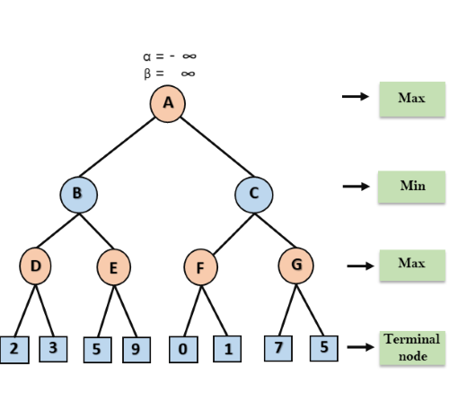

**Step 2:** At Node D, the value of α will be calculated as its turn for Max. The value of α is compared with firstly 2 and then 3, and the max (2, 3) = 3 will be the value of α at node D and node value will also 3.

**Step 3:** Now algorithm backtrack to node B, where the value of β will change as this is a turn of Min, Now β= +∞, will compare with the available subsequent nodes value, i.e. min (∞, 3) = 3, hence at node B now α= -∞, and β= 3.

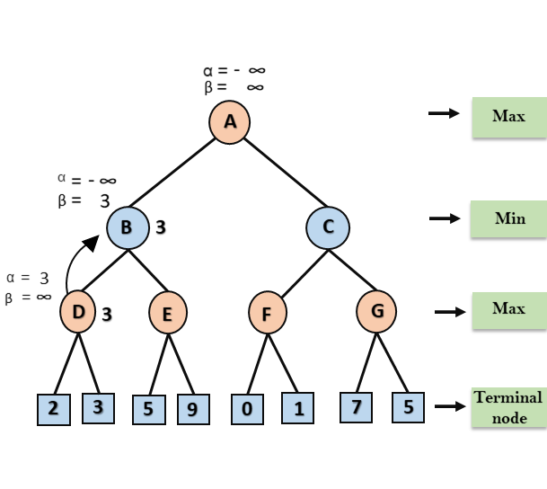

In the next step, algorithm traverse the next successor of Node B which is node E, and the values of α= -∞, and β= 3 will also be passed.

**Step 4:** At node E, Max will take its turn, and the value of alpha will change. The current value of alpha will be compared with 5, so max (-∞, 5) = 5, hence at node E α= 5 and β= 3, where α>=β, so the right successor of E will be pruned, and algorithm will not traverse it, and the value at node E will be 5.

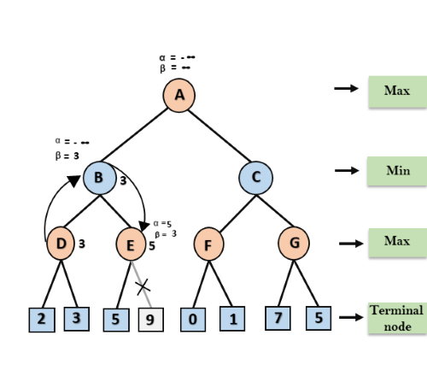

**Step 5:** At next step, algorithm again backtrack the tree, from node B to node A. At node A, the value of alpha will be changed the maximum available value is 3 as max (-∞, 3)= 3, and β= +∞, these two values now passes to right successor of A which is Node C.

At node C, α=3 and β= +∞, and the same values will be passed on to node F.

**Step 6:** At node F, again the value of α will be compared with left child which is 0, and max(3,0)= 3, and then compared with right child which is 1, and max(3,1)= 3 still α remains 3, but the node value of F will become 1.

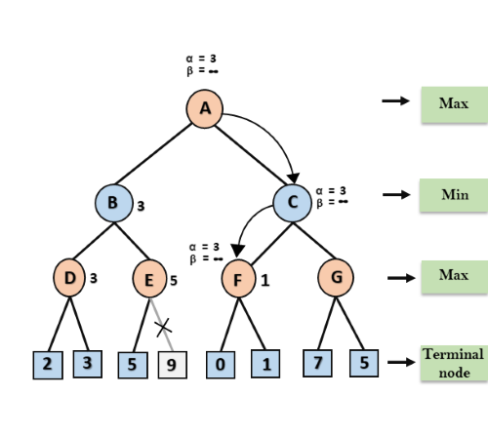

**Step 7:** Node F returns the node value 1 to node C, at C α= 3 and β= +∞, here the value of beta will be changed, it will compare with 1 so min (∞, 1) = 1. Now at C, α=3 and β= 1, and again it satisfies the condition α>=β, so the next child of C which is G will be pruned, and the algorithm will not compute the entire sub-tree G.

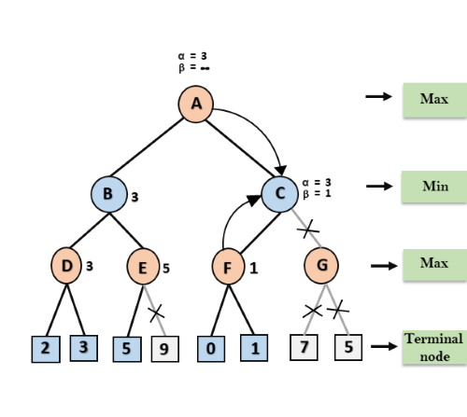

**Step 8:** C now returns the value of 1 to A here the best value for A is max (3, 1) = 3. Following is the final game tree which is the showing the nodes which are computed and nodes which has never computed. Hence the optimal value for the maximizer is 3 for this example.

